
INVITATION TO SUBMIT PRICE QUOTATION FORM
The Provincial Government of Davao del Norte, through its Bids and Awards Committee (BAC) invites suppliers/manufacturer/distributors/contractors to submit Price Quotation for the following:
PQF NO. | PR No. | Name of Project/s | R.O. | ABC
C20171730 | 1706-2232 | Sound System for installation at New PDRRMD Bldg. | DRRMD | 122,546.60
C20171731 | 1706-2204 | Combi blinds for New PDRRMD Bldg. | DRRMD | 135,072.00
C20171752 | 1705-2105 | Flowers/Florist for Mass Committee in the celebration of the Araw Ng Davao 2017 | PASSO | 110,000.00
C20171753 | 1705-2108 | Leis & Logo for Event Committee in the celebration of the Araw ng Davao del Norte 2017 | PASSO | 75,550.00
C20171754 | 1705-2139 | Airconditioning unit for use of OSS | OSS | 410,000.00

The complete schedule of the activities is listed, as follows:
ACTIVITY | DATE/S
1. Issuance of Price Quotation Forms | June 13, 2017 – June 15, 2017  Procurement Planning & Purchasing Section, 2nd Floor, PGSO Bldg. Government Center, Mankilam,Tagum City, DDN
2. Opening of Shopping & Small Value Procurement | June 16, 2017, 09:00 A.M.  PGSO Conference Room¸2nd Floor, PGSO Bldg. Government Center, Mankilam,Tagum City, DDN

Shopping Form may be secured / obtained at the BAC Secretariat, 2F PGSO Building, Government Center, Mankilam, Tagum City, Davao del Norte.

BAC 2017-06-22 | ATTY. EDD MARK O. WAKAN  Provincial General Services Officer  BAC-Chairman
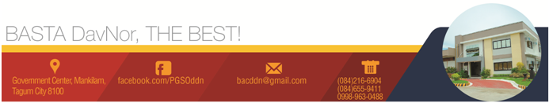
Date of Publication: June 13, 2017

